BSG Operations Intelligence Agent
for Data Labeling Services

Strategic Concept Proposal

A forward-looking AI transformation vision for data operations

Prepared for strategic review and leadership discussion
Confidential concept document

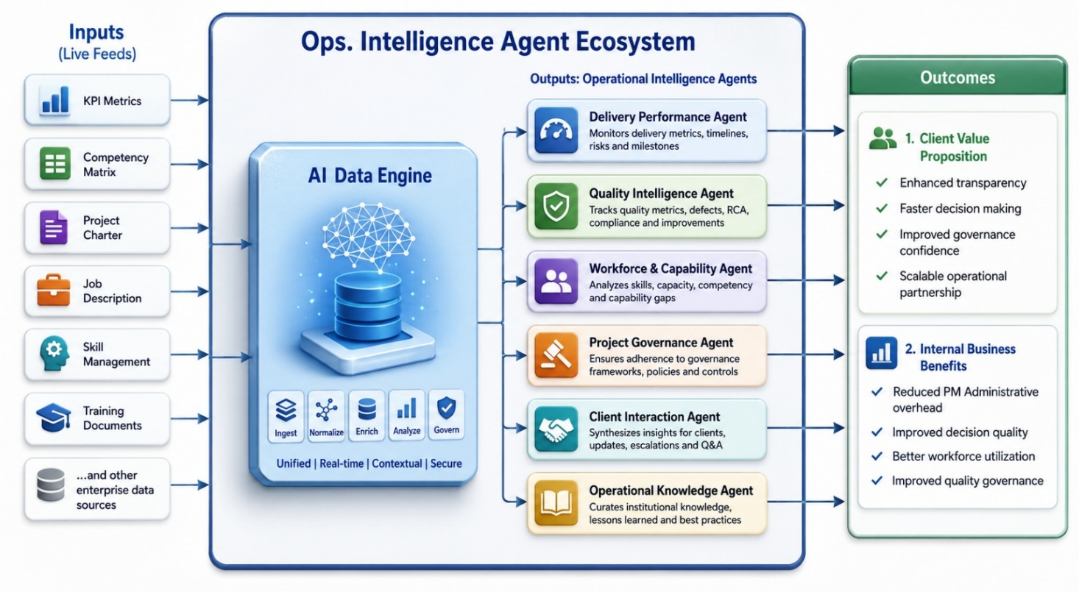

Table of Contents
1. Executive Narrative 4
From Data Labeling Vendor to AI-Native Operational Partner 4
2. Strategic Positioning 4
The Future Positioning of BSG 4
BSG's AI Strategy 4
3. Industry Context & Why This Matters 5
Current Operational Challenges in Data Programs 5
4. Vision Statement 5
BSG AI-Native Operations Suite 5
5. The AI-Native Operations Suite 5
Concept Overview 5
6. Core Design Principles 6
7. Proposed "Operations Intelligence Agent Ecosystem" 6
A. Operational Intelligence Agents 6
1. Delivery Performance Agent 6
2. Quality Intelligence Agent 6
3. Workforce & Capability Agent 6
4. Project Governance Agent 6
5. Client Interaction Agent 7
6. Operational Knowledge Agent 7
7.1 BRD - Delivery Performance Agent 7
a. Executive Overview - Mandate 7
b. Strategic Objective 8
c. Agent Mission Statement 8
d. Primary User Personas 8
e. Business Problems, Objectives & Key Questions 8
f. AI Agent Capabilities 8
g. Data Inputs & Reasoning Logic 9
h. Requirements, Outputs & Architecture 9
7.5 BRD - Client Interaction Agent 9
a. Executive Overview — Mandate 10
b. Strategic Objective 10
c. Agent Mission Statement 10
d. Primary User Personas 10
e. Business Problems, Objectives & Key Questions 10
f. AI Agent Capabilities 10
g. Data Inputs & Reasoning Framework 11
h. Requirements, Outputs & Architecture 11
8. Platform Architecture 11
Three-Layer AI Architecture 11
Layer 1 — Unified Data Foundation 11
Layer 2 — Intelligence & Analytics Layer 12
Layer 3 — Conversational AI Interaction Layer 12
9. Sample Operational Use Cases 12
Use Case 1 — Milestone Risk Prediction 12
Use Case 2 — AI-Assisted Client Reporting 12
Use Case 3 — Workforce Optimization 12
Use Case 4 — Quality Drift Detection 12
10. Client Value Proposition 12
Why Clients Will Care 12
11. Internal Business Benefits 13
Operational Benefits 13
12. AI Governance & Security Model 13
Foundational Principle 13
13. Transformation Roadmap 13
14. Success Metrics 14
15. Strategic Outcome 14
The Bigger Vision 14
16. Final Strategic Narrative 14
The Story BSG Can Tell the Market 14
Appendix — Example Questions the AI Suite Can Answer 15
Delivery & Operations 15
Quality & Governance 15
Workforce & Capability 15
Client & Leadership 15

1. Executive Narrative
From Data Labeling Vendor to AI-Native Operational Partner
The Data Labeling domain is rapidly evolving. Clients are no longer evaluating vendors solely on delivery capacity or annotation throughput, they increasingly seek strategic partners offering operational intelligence, predictive project governance, workforce optimization, and transparent delivery management.

BSG has the opportunity to position itself as an AI-Native Operations Organization: delivering intelligent, scalable, and insight-driven execution. This proposal outlines the BSG AI-Native Operations Suite: a modular ecosystem of AI Agents designed to enhance operational efficiency, project governance, workforce management, quality management, and client transparency across Data Labeling programs.

Importantly, this initiative is not focused on replacing human annotation work with AI. The vision is to build an AI-powered operational layer around the delivery ecosystem that enables faster decision-making, reduced PM overhead, objective insights, predictive intelligence, standardized client communication, and scalable operational maturity.

2. Strategic Positioning

The Future Positioning of BSG
Today: A high-quality data operations and labeling services provider.
Future State: An AI-Native Operations Partner powered by intelligent operational agents.

BSG's AI Strategy
Most competitors are exploring AI primarily for annotation automation. BSG's differentiation is fundamentally unique; rather than replacing human expertise, BSG enhances operational excellence through AI-enabled orchestration:
Traditional Operations | AI-Native Operations
Manual reporting | Real-time operational intelligence
Spreadsheet-driven governance | Unified AI-driven decision support
Reactive issue handling | Predictive risk identification
PM-dependent responses | AI-assisted evidence-backed insights
Static dashboards | Conversational operational intelligence
Delayed client updates | Real-time transparency and insights
"BSG combines human scientific expertise with AI-enabled operational intelligence to deliver scalable, transparent, and future-ready data operations."

3. Industry Context & Why This Matters

Current Operational Challenges in Data Programs
Data operations environments consistently surface the same pain points:
- Operational Complexity: programs involve multiple stakeholders, distributed teams, dynamic quality requirements, and tight delivery timelines.
- Fragmented Operational Data: intelligence is spread across Excel trackers, QA logs, workforce sheets, Power BI dashboards, and SOP repositories, creating inefficiencies and decision delays.
- High PM Overhead: project managers spend substantial effort on status reporting, resource allocation, risk analysis, and client updates, reducing focus on strategic governance.
- Inconsistent Visibility: different teams operate with different metrics and different versions of operational truth, undermining alignment and client confidence.
- Increasing Client Expectations: clients increasingly demand real-time visibility, predictive insights, quality traceability, and governance maturity. The market is shifting toward intelligent operational partnerships.

4. Vision Statement

BSG AI-Native Operations Suite
Vision: To build a unified AI-powered operational intelligence ecosystem that transforms data labeling operations into a proactive, scalable, transparent, and insight-driven delivery model.
Core Objective: Enable BSG teams and clients to interact with operational intelligence through AI-driven, evidence-backed, role-based experiences.

5. The AI-Native Operations Suite

Concept Overview
The proposed solution is an integrated suite of specialized AI Agents operating on top of a centralized operational intelligence layer. The platform unifies operational data, workforce intelligence, delivery metrics, quality signals, governance artifacts, historical trends, and client reporting structures into a single AI-enabled ecosystem.

6. Core Design Principles
- Human-Centric AI: AI augments operational teams; it does not replace scientific reviewers, SMEs, or annotation specialists.
- Single Source of Truth: All operational intelligence is grounded in governed, validated data.
- Evidence-Backed AI: Every AI-generated insight must be traceable to operational evidence.
- Role-Based Intelligence: Different stakeholders receive tailored insights based on role and permissions.
- Operational Explainability: Insights must explain what happened, why, the impact, recommended actions, and confidence level.
- Security & Governance First: No client data usage without explicit approvals, RBAC controls, audit logging, and governance validation.

7. Proposed "Operations Intelligence Agent Ecosystem"

A. Operational Intelligence Agents

1. Delivery Performance Agent
Provides: milestone tracking, throughput analysis, delivery forecasting, bottleneck identification, schedule confidence scoring, and risk escalation alerts.
Answers: Which projects are at delivery risk? What changed since last week? Which workflow is slowing throughput?

2. Quality Intelligence Agent
Provides: error trend analysis, quality drift monitoring, reviewer consistency insights, rework analysis, root-cause intelligence, and training recommendation triggers.
Answers: Is quality impacting delivery velocity? Which error categories are increasing?

3. Workforce & Capability Agent
Provides: skill-to-project matching, SME coverage analysis, workforce utilization insights, certification tracking, and resource planning recommendations.
Answers: Do we have sufficient SME coverage? Which teams are overloaded?

4. Project Governance Agent
Provides: charter generation, governance tracking, scope change analysis, dependency visibility, escalation summaries, and action tracking.
Answers: What are the top governance risks? Which dependencies threaten timelines?

5. Client Interaction Agent
Provides: AI-assisted status updates, real-time client Q&A, executive-ready summaries, transparency dashboards, and delivery confidence reporting.
Answers: What is the current project health? Which milestones are at risk?

6. Operational Knowledge Agent
Provides: SOP retrieval, process guidance, historical issue referencing, best-practice recommendations, and context-aware operational assistance.
Answers: How is quality trending this month?

7.1 BRD - Delivery Performance Agent
Operational Decision Intelligence | Functional, Data, and Architecture Requirements
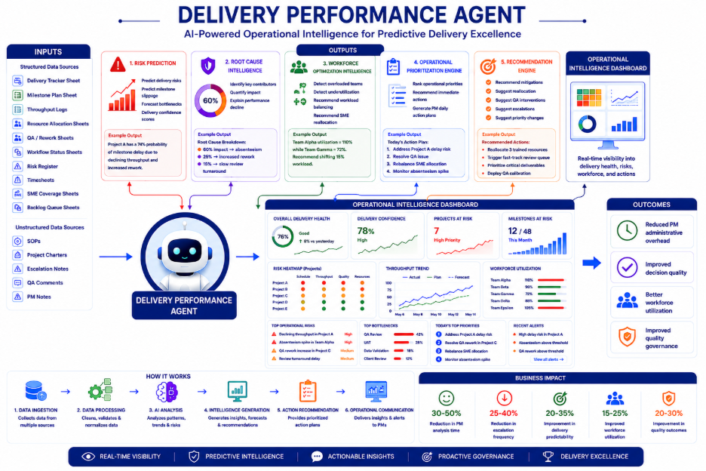

a. Executive Overview - Mandate
The Delivery Intelligence Agent is an AI-native operational intelligence system designed to continuously monitor delivery execution across data operations programs and provide predictive, actionable, and evidence-backed recommendations. It transforms fragmented delivery workflows into a proactive decision-support ecosystem, helping Project Managers, Delivery Leads, and Operations teams predict delivery risks, detect bottlenecks, optimize workforce utilization, and reduce escalation frequency.

b. Strategic Objective
Build an AI-native delivery intelligence layer capable of monitoring operational health in real time, predicting schedule risks, recommending mitigation actions, prioritizing interventions, and reducing reactive operational management.

c. Agent Mission Statement
"Continuously monitor delivery execution signals, identify operational risks, predict delivery outcomes, recommend mitigation strategies, and generate prioritized operational action plans for delivery leadership."

d. Primary User Personas
Persona | Primary Need
Project Managers | Daily operational prioritization
Delivery Leads | Portfolio delivery governance
Operations Managers | Workforce balancing & throughput management
QA Leads | Quality-driven delivery risk visibility
Program Leadership | Delivery forecasting & operational transparency
Resource Managers | Utilization and SME allocation insights

e. Business Problems, Objectives & Key Questions
The agent addresses: PMs spending excessive time on spreadsheets, reactive delay management, lack of real-time visibility, difficulty identifying root causes, inefficient workforce utilization, and absence of predictive delivery governance.
It answers: Which projects are at risk? Which milestones will slip? Are teams optimally utilized? What should the PM focus on today?

f. AI Agent Capabilities
- Delivery Risk Prediction: detects throughput decline and predicts slippage probability. Example: "Project A has a 74% probability of milestone delay due to declining throughput and increased rework."
- Root Cause Intelligence: quantifies contributors: e.g., 60% absenteeism, 25% rework, 15% slow review turnaround.
- Workforce Optimization: recommends rebalancing between overloaded/underutilized teams. Example: "Team Alpha 110% vs Team Gamma 72% - shift 15% workload."
- Prioritization & Recommendation Engine: generates ranked PM daily action plans, mitigation strategies, resource reallocations, and QA interventions.

g. Data Inputs & Reasoning Logic
Structured sources: Delivery Tracker, Milestone Plan, Throughput Logs, Resource Allocation, QA/Rework Sheets, Risk Register, and Backlog Queue.
Unstructured: SOPs, Project Charters, Escalation Notes, and PM Notes.
Reasoning: IF throughput declines AND rework increases AND absenteeism spikes THEN raise risk score, forecast delay probability, generate mitigations, trigger escalation alert. Outputs risk tiers: Low / Medium / High / Critical.

h. Requirements, Outputs & Architecture
Key functional requirements: Natural Language Query Interface, Delivery Forecasting, Root Cause Analysis, Recommendation Generation, Operational Alerting, and PM Daily Action Dashboard.
Outputs: Action Plans, Confidence Scores, Risk Summaries, Throughput Forecasts, Workforce Recommendations, and Escalation Reports.
Non-functional: multi-project scalability, near real-time latency, RBAC security, full audit traceability.
Core architecture: KPI semantic layer, RAG framework, operational vector database, time-series engine, and LLM orchestration.
Future: autonomous workflow orchestration, multi-agent collaboration, self-improving recommendation engine.

7.5 BRD - Client Interaction Agent
Client Transparency Intelligence | Functional, Data, and Architecture Requirements
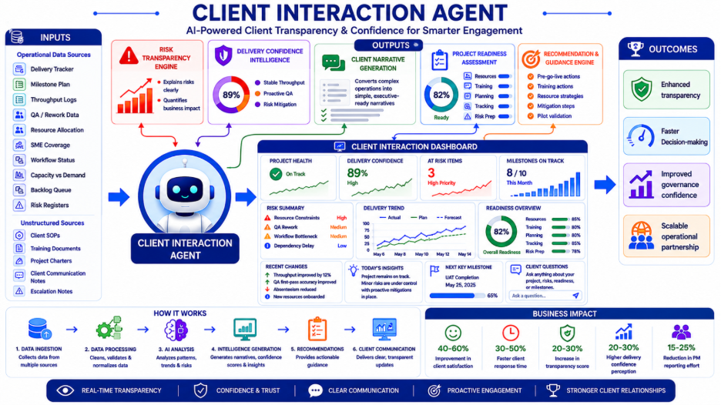

a. Executive Overview - Mandate
The Client Intelligence Agent is an AI-native client engagement and operational transparency system that transforms delivery data into executive-ready narratives, confidence-driven communication, predictive project transparency, and operational trust signals. It enables clients to understand delivery health, identify risks early, and access real-time visibility, without depending entirely on PM-driven reporting cycles.

b. Strategic Objective
Build an AI-native client transparency layer capable of improving client confidence, enhancing transparency, accelerating communication, reducing uncertainty, simplifying operational complexity, and enabling proactive engagement.

c. Agent Mission Statement
"Continuously translate operational delivery intelligence into transparent, explainable, confidence-based client narratives and actionable engagement insights."

d. Primary User Personas
Persona | Primary Need
Client Stakeholders | Delivery visibility
Client Program Managers | Operational transparency
Client Leadership | Executive-level confidence
Internal PMs | AI-assisted communication
Delivery Leadership | Relationship governance

e. Business Problems, Objectives & Key Questions
The agent solves: slow client response cycles, inconsistent operational narratives, reactive communication, low confidence during volatility, manual update preparation, and lack of structured readiness evaluation.
It answers: Is my project on track? Why is there a delay? Are we ready to start? What risks exist before go-live?

f. AI Agent Capabilities
- Client Narrative Generation: converts operational complexity into simple, executive-ready summaries. Example: "Projects remain on track with minor fluctuations that have already been mitigated."
- Delivery Confidence Intelligence: generates confidence scores and predicts milestone reliability. Example: "Milestone confidence is 89% due to stable throughput and proactive QA interventions."
- Risk Transparency Engine: translates operational issues into business language and highlights mitigation progress. Example: "Resource constraints were identified and mitigated through additional trained resource deployment."
- Project Readiness Assessment: scores readiness across resource, training, planning, tracking, and risk preparedness dimensions, with gap analysis.
- Recommendation & Guidance Engine: recommends pre-go-live actions, resource strategies, and pilot validation approaches.

g. Data Inputs & Reasoning Framework
Structured: Delivery Tracker, Milestone Plan, Throughput Logs, QA/Rework Sheets, Resource Allocation, SME Coverage, and Risk Registers.
Unstructured: Client SOPs, Training Documents, Project Charters, and Escalation Notes. Reasoning: translates operational complexity into business-friendly narratives, balancing transparency with reassurance.
Readiness logic considers SME availability, training completion, historical performance, and quality preparedness, thus outputting readiness score, gap analysis, confidence level, and mitigation recommendations.

h. Requirements, Outputs & Architecture
Key functional requirements: Client Conversational Interface, Confidence Score Generation, Readiness Assessment Engine, Executive Summary Generation, and Client Risk Explanation Engine.
Outputs: Project Health Summaries, Executive Status Reports, Delivery Confidence Scores, Readiness Reports, Risk Narratives, and Go-Live Readiness Reports.
Governance: no hallucinated project status, all narratives evidence-backed, confidence scoring mandatory, and sensitive data protection required.
Core architecture: KPI semantic layer, narrative generation framework, RAG architecture, confidence scoring engine, and role-based access layer.
Future: multi-client portfolio intelligence, AI relationship sentiment analysis, and predictive client escalation detection.

8. Platform Architecture

Three-Layer AI Architecture

Layer 1 - Unified Data Foundation
Creates the operational single source of truth by normalizing data from delivery dashboards, resource matrices, quality reports, SOP repositories, skill databases, timesheets, and governance artifacts. Capabilities: data normalization, KPI standardization, semantic modeling, governance validation, and auditability.

Layer 2 - Intelligence & Analytics Layer
Transforms operational data into intelligence through predictive analytics, trend detection, anomaly detection, root-cause analysis, forecasting, risk scoring, pattern recognition, and workforce optimization.

Layer 3 - Conversational AI Interaction Layer
Enables natural language interaction with operational intelligence through conversational Q&A, AI-generated summaries, automated reporting, action recommendations, role-based responses, evidence citation, and document generation.

9. Sample Operational Use Cases

Use Case 1 - Milestone Risk Prediction
The AI Suite identifies declining throughput, increased rework, resource overload, and delayed review cycles — then predicts milestone risk before escalation occurs.

Use Case 2 - AI-Assisted Client Reporting
The AI Suite automatically generates weekly summaries, executive updates, quality narratives, and delivery confidence insights, reducing PM overhead while improving consistency.

Use Case 3 - Workforce Optimization
The AI Suite identifies underutilized SMEs, capability shortages, and high-risk resource dependencies, enabling proactive workforce planning.

Use Case 4 - Quality Drift Detection
The AI Suite continuously monitors error trends, annotation inconsistencies, and rework patterns, enabling early corrective intervention.

10. Client Value Proposition

Why Clients Will Care
The AI-Native Operations Suite creates measurable client value beyond traditional delivery execution:
- Enhanced Transparency: real-time visibility, evidence-backed reporting, and consistent operational narratives.
- Faster Decision-Making: immediate access to insights, reducing dependency on manual reporting cycles.
- Improved Governance Confidence: traceable insights, consistent metrics, and AI-assisted root-cause analysis.
- Scalable Operational Partnership: BSG evolves from vendor to strategic AI-enabled operational partner.

11. Internal Business Benefits

Operational Benefits
- Reduced PM Administrative Overhead: automation of status reporting, summary generation, governance tracking, and client response preparation.
- Improved Decision Quality: faster access to data-backed recommendations with reduced manual consolidation.
- Better Workforce Utilization: improved skill matching, reduced allocation inefficiencies, and better capacity risk visibility.
- Improved Quality Governance: early quality signal detection, faster issue remediation, and better training alignment.

12. AI Governance & Security Model

Foundational Principle
Security, governance, and trust are foundational, not optional. The platform includes role-based access control (RBAC), permission-aware AI responses, audit logging, human-in-the-loop validation, governance approval workflows, and data lineage tracking.
Initial development and testing will use synthetic datasets and sanitized operational structures. Production deployment will require explicit client approvals, governance sign-offs, security validation, and compliance review.

13. Transformation Roadmap
Phase | Objectives
Phase 0 — Vision & Alignment | Define business objectives, success metrics, operational priorities, target user personas, and AI governance principles.
Phase 1 — Data & KPI Foundation | Establish unified KPI framework, semantic operational model, data mapping, operational taxonomy, and governance structure.
Phase 2 — AI Agent MVP | Develop operational Q&A, risk detection, automated reporting, resource intelligence, and client insight generation.
Phase 3 — Pilot Deployment | Pilot with internal delivery teams using sanitized operational datasets, human-reviewed outputs, and controlled stakeholder access.
Phase 4 — Scaled Rollout | Expand toward multi-program intelligence, client-facing experiences, portfolio analytics, and enterprise operational AI ecosystem.

14. Success Metrics
Operational: reduction in PM reporting effort, faster issue detection, reduced client response turnaround, improved resource utilization, increased delivery predictability.
Client: improved transparency scores, faster insight access, increased client satisfaction, improved governance confidence.
AI Quality: insight accuracy, grounding quality, hallucination prevention, evidence traceability, and permission compliance.

15. Strategic Outcome

The Bigger Vision
The AI-Native Operations Suite is more than an internal productivity initiative. it represents a strategic transformation in how BSG delivers operational services. The long-term outcome is a differentiated operational model where human scientific expertise remains central, AI enhances operational intelligence, clients gain unprecedented transparency, delivery governance becomes predictive rather than reactive, and workforce orchestration becomes intelligent and scalable.

16. Final Strategic Narrative

The Story BSG Can Tell the Market
"BSG is building an AI-Native operational ecosystem for data operations - combining scientific expertise, operational excellence, and AI-driven intelligence to deliver scalable, transparent, and future-ready partnership models."

This narrative positions BSG as forward-looking, operationally mature, AI-enabled, governance-focused, client-centric, scalable, and innovation-driven, without compromising the importance of human expertise in Vertical workflows.

Appendix - Example Questions the AI Suite Can Answer

Delivery & Operations
- Which milestones are most at risk this month?
- Why did throughput decline this week?
- Which projects require escalation attention?
- What changed operationally since the last reporting cycle?

Quality & Governance
- Are quality trends affecting delivery timelines?
- Which error categories are increasing?
- Which projects require additional QA intervention?

Workforce & Capability
- Do we have sufficient SME coverage?
- Which teams are nearing capacity overload?
- What training gaps may impact delivery?

Client & Leadership
- Provide an executive-ready project health summary.
- Summarize delivery risks with mitigation plans.
- Generate this week's client update.
- Forecast delivery confidence for the next milestone.

